NEW PROCEDURES FOR PROCESSING CORTICAL EEG DATA: AUDITORY/VISUAL TASK

Although this tutorial will teach you how to process raw EEG data using the graphical user interface (GUI) in EEGLab, each step can also be performed on the command line, which in turn can be put together as a MATLAB script.

MATLAB command line instructions will be highlighted in the light blue boxes.

# Enable EEGLab

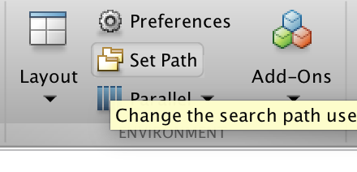

Place the EEGLab directory into MATLAB’s path by clicking on “Set Path” in the “Home” tab of MATLAB. You’ll only need to add the main EEGLab directory to the path without the subfolders. Click on “Add folder…”

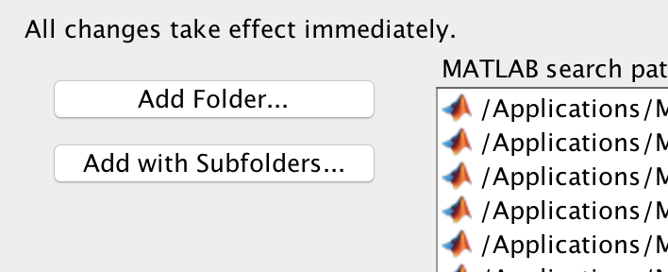

You’ll need to locate where your copy of EEGLab is (typically named something like: eeglab13_6_5b).

When you’re done, click “Close”. MATLAB may ask you “Do you want to save the current path for use in future MATLAB session?” Click “No”

TO DO THE SAME THING ON THE COMMAND LINE type:

>> addpath(‘your_EEGLab_path’);

Where ‘your path name here’ is a string (denoted by the single quotes at the beginning and end of the string). Mine, for example is:

‘/Users/scbressler/Documents/MATLAB/eeglab13_6­_5b/’

Next, you’ll have to start EEG Lab. This can only be done on the command line.

>> eeglab

Starting EEG Lab this way will let the program place the rest of the necessary directories into MATLAB’s path. This only has to be done once per MATLAB session, so if you quit and restart MATLAB, you’ll have to do the above steps all over again.

**TIP**: By the way, if you accidentally close your EEGLab window, as long as you haven’t cleared the variables, you can get it back by typing:

>> eeglab redraw

# EEGLab should now be open

A new window will pop up and your Workspace will be populated with a collection of new variables.

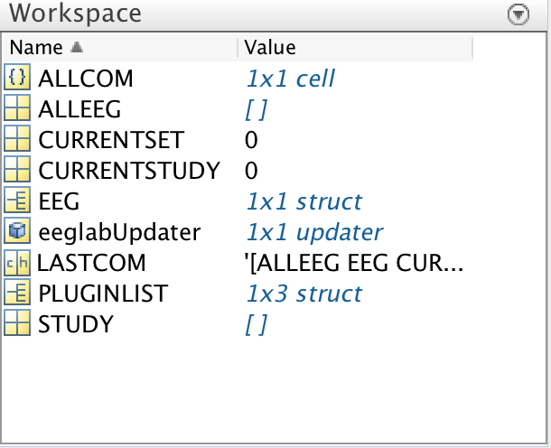

We will mainly be using only 4 of the 9 variables in the workspace.

* ALLEEG: a 1 x N structure that grows with each new dataset added
* EEG: a 1x1 structure that is a copy of ALLEEG structure that you’re currently working on
* ALLCOM: EEGLab keeps a record of all your GUI moves as a 1xN cell
* LASTCOM: a copy of the last cell in ALLCOM, basically the last command you ran

# Import the raw BDF file

To import your raw BDF file, click on:

File → Import data → Using EEGLAB functions and plugins → From Biosemi BDF file (BIOSIG toolbox)

It may tell you that you don’t have the right toolbox, and ask you if you want to download it. Do it.

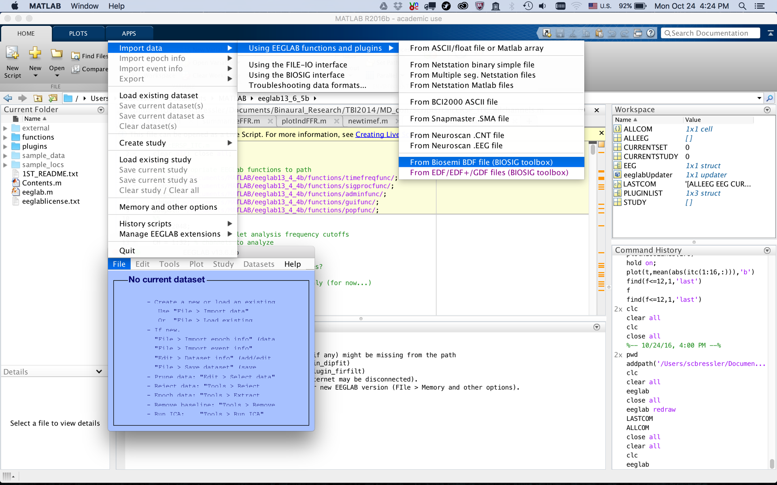

A file browser GUI will pop up. Navigate to your BDF file and select “Open”. Another window will pop up asking you to fill in some file parameters.

The only parameter you’ll need to fill in is the:

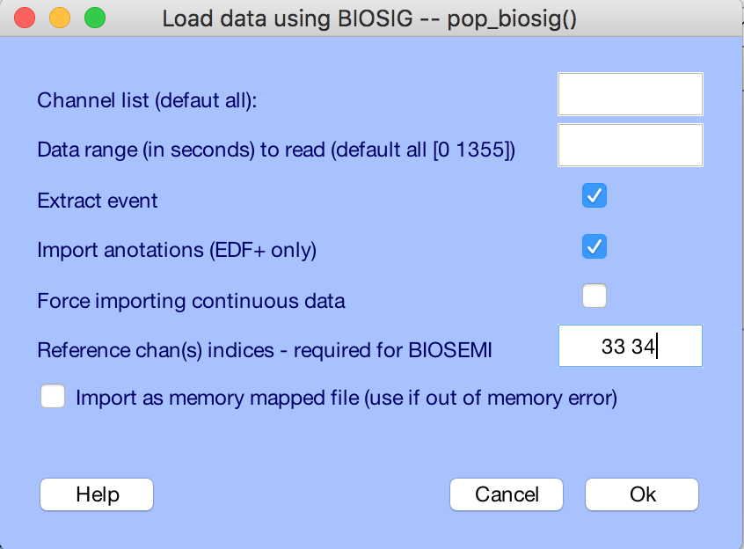

Reference chan(s) indices-required for BIOSEMI

33 34 refers to external electrodes EXG1 and EXG2, the mastoids.

You can go ahead and click “OK”. Loading the file takes a little while (no more than a couple of minutes at the most). When EEGLab is done, a new window will pop up asking you to name the new dataset. Enter in the subject ID # preceded by ‘s’

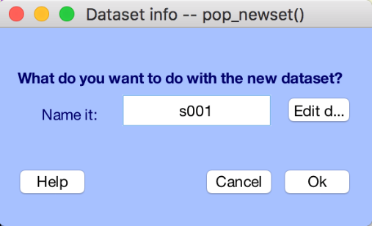

Click “OK”

At this point, the data is loaded. You’ll see variables in your Workspace have been updated, and the EEGLab GUI has been partially filled in.

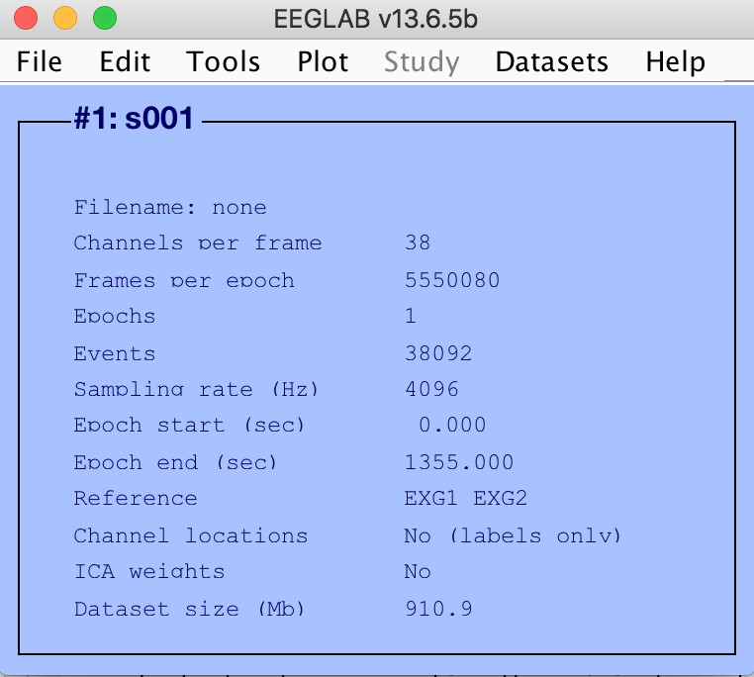

Some important things to check:

* Channels per frame = 38

32 scalp channels + 8 externals – 2 reference

* Epochs = 1
* Sampling rate (Hz) = 4096
* Reference = EXG1 EXG2

Right now, the data is one very long epoch with 5,550,080 samples (or what EEGLab calls ‘frames’). ‘Events’ refer to the event triggers, both the regular 16-bit triggers and the 4 diodes.

>> EEG = pop_biosig('/DATAraw/VisualFFR/1/1_2016_06_24.bdf','ref',[33 34],'refoptions',{'keepref' 'off'});

You can replace '/DATAraw/VisualFFR/1/1_2016_06_24.bdf' with the path and file name of your specific BDF file.

# Removing unwanted channels

Since we recorded data on 35 channels (not counting the mastoid references that have already been removed from the list), we can go ahead and remove the additional 3 external channels from the file.

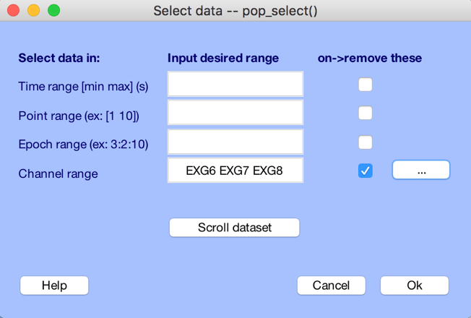

Click on Edit → Select data. Select the “on->remove these” option next to the “Channel range” row. Enter “EXG6 EXG7 EXG8” in the text box.

You can also click on the pop up menu, the “…” box highlighted in green, and select from the entire list of channels.

EEG = pop_select( EEG,'nochannel',{'EXG6' 'EXG7' 'EXG8'});

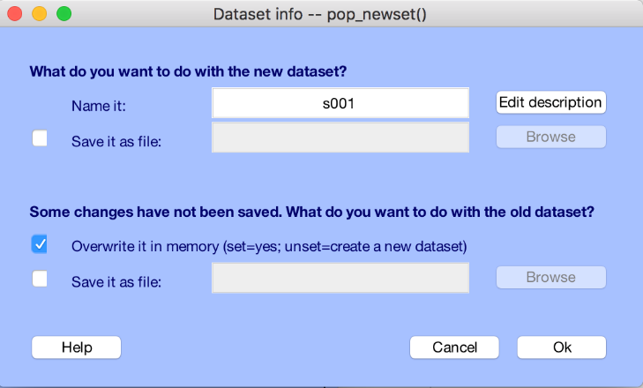 {‘EXG3’,’EXG4’,’EXG5’,’EXG6’,’EXG7’,’EXG8’,’GSR1’,’GSR2’,’Erg1’,’Erg2’,’Resp’,’Plet’,’Temp’}

Every time you manipulate a dataset, EEGLab will ask you if you want to save it as a new dataset, or overwrite the data to the existing dataset name.

In this case, we’ll just overwrite the existing dataset. The dataset name will be the one listed in the “Name it” field, here ‘s001’.

In future steps, we’ll be creating new datasets with appended names to keep track of our progress.

>> [ALLEEG EEG CURRENTSET] = pop_newset(ALLEEG, EEG, 0,'setname','s001','gui','off');

# Changing the sampling rate

Highly sampled data, like ours at 4096 Hz or samples/sec, takes up a lot of space, which in turn takes longer to process. Cortical EEG data really only has meaningful content below 100 Hz. Based on the Nyquist rate, which says we need a minimum sampling rate of 200 Hz (2 x 100 Hz), we’ll downsample our data to 256 Hz.

Click on Tools → Change sampling rate. Enter “256” in the text field and click “OK”

EEG = pop_resample( EEG, 256);

Again, we’re going to overwrite the dataset. You’ll notice that EEGLab named the new dataset “s001 resampled” by default. Change this back to “s001”, check the “Overwrite it in memory” box, and click “Ok”.

[ALLEEG EEG CURRENTSET] = pop_newset(ALLEEG, EEG, 1,'setname','s001','overwrite','on','gui','off');

# Bandpass filter the data

To address low frequency drift and high frequency noise from muscle contractions and the 60-cycle power service, we have to bandpass filter the data between 0.1 and 50 Hz.

Select Tools → Filter the data →Windowed sinc FIR filter.

In the “Cuttoff frequency(ies) [hp lp] (-6 dB; Hz)” field to “0.1 50”

Leave the “Filter type:” field to “Bandpass”

Change the “Window type:” field to “Kaiser”

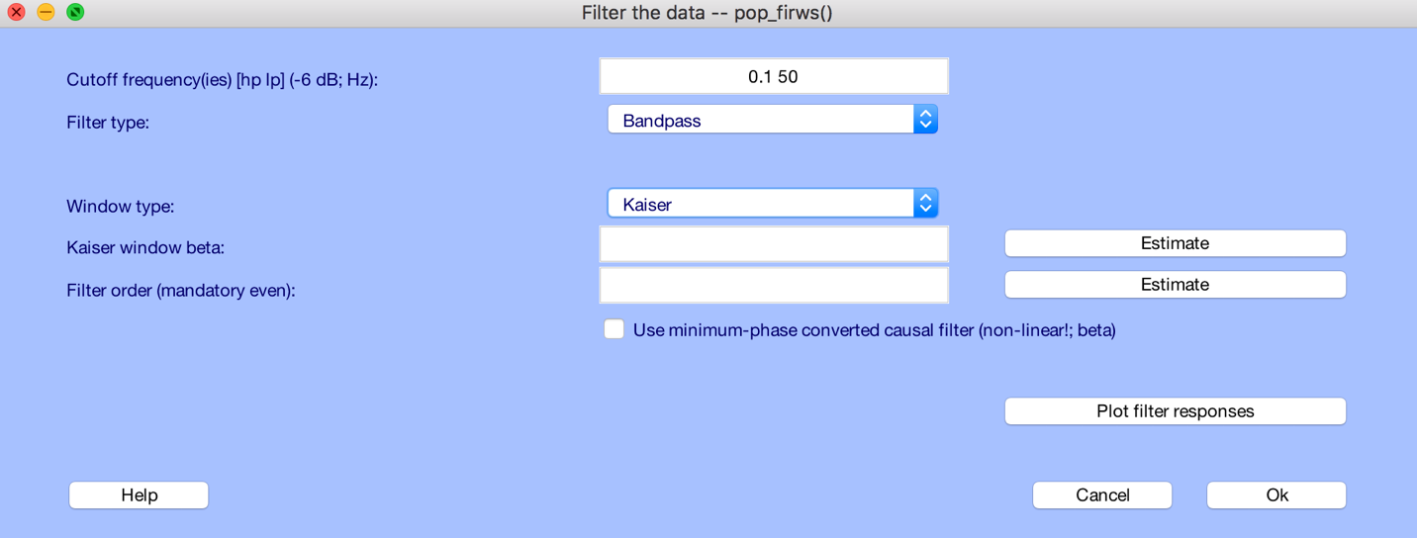

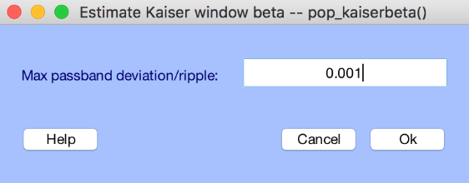

To get the “Kaiser window beta:” value, click on “Estimate”. Set the “Max passband deviation/ripple:” to “0.001”.

Click “Ok”

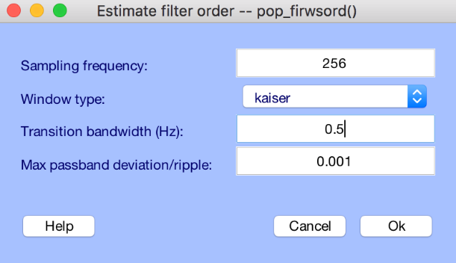

To get the “Filter order (mandatory even):” value, click on “Estimate”. Set the “Transition bandwidth (Hz):” to “0.5”.

Click “Ok”

You’ll now see that the Kaiser window beta is 5.65326, and the Filter order is 1856. Go ahead and click “Ok”

EEG = pop_firws(EEG, 'fcutoff', [0.1 50], 'ftype', 'bandpass', 'wtype', 'kaiser', 'warg', 5.65326, 'forder', 1856, 'minphase', 0);

This time we’re going to save this as a new dataset. In the “Name it:” field enter “s100 BPF” to let us know this bandpass filtered data. Make sure the “Overwrite it in memory..” checkbox is unchecked—it should be by default, and click “Ok”

[ALLEEG EEG CURRENTSET] = pop_newset(ALLEEG, EEG, 1,'setname','s001 BPF','gui','off');

# Cleaning up the data before running ICA

Before we calculate the independent components, we need to remove data that is obviously the result of spurious experimental artifacts. To look at the channel-by-channel voltages across time, select Plot → Channel data (scroll).

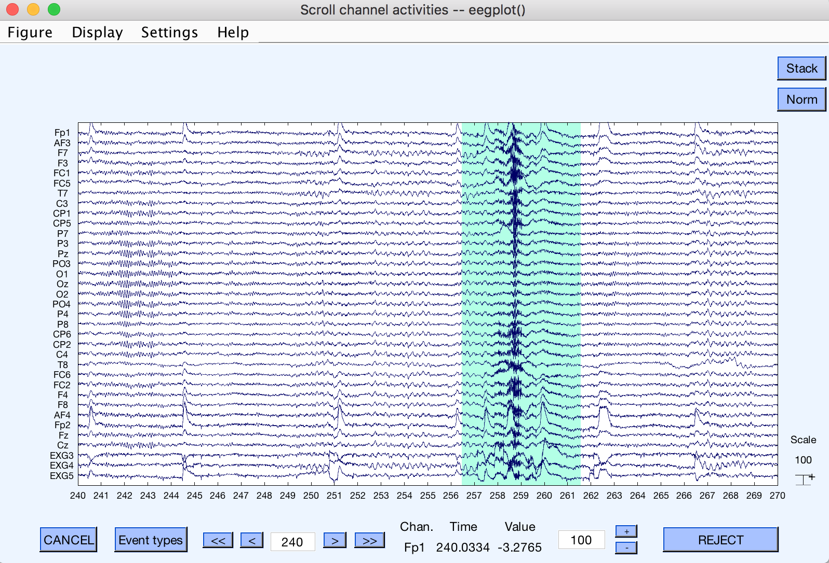

First, you’ll want to shut off all the event trigger information (the colored vertical lines). Select Settings → Events → Events off. This is speed up the graphics rendering as you scroll through the data.

Next change the time axis (x-axis) range. Select Settings → Time range to display. Set the “New window length (s):” field to 30. This will show the data in 30-second chunks.

To change the voltage axis (y-axis) range, you can enter in different values in the text box highlighted in green (above). I’ve found 100 (µV) is works pretty well.

Now you can scroll through the data using the <<, <, >, and >> buttons. Highlight data regions that are clearly bad (see example above). Look for muscle artifacts and signal discontinuities in particular. This is a very subjective process, but since we’re working with the entire dataset, you can be conservative. If you make a mistake, click on the highlighted region to deselect it. Go through the whole set, and click “Reject” when you’re done.

There is no automated MATLAB script to do this step

Now save the dataset as “s001 BPF CU” for bandpass filtered data that has been Cleaned Up.

[ALLEEG EEG CURRENTSET] = pop_newset(ALLEEG, EEG, 2,'setname','s001 BPF CU','gui','off');

# Adding channel location data

In order look at the scalp distributions of the different ICA components, we need to add channel location data to the dataset.

Select Edit → Channel locations

Click “Cancel”

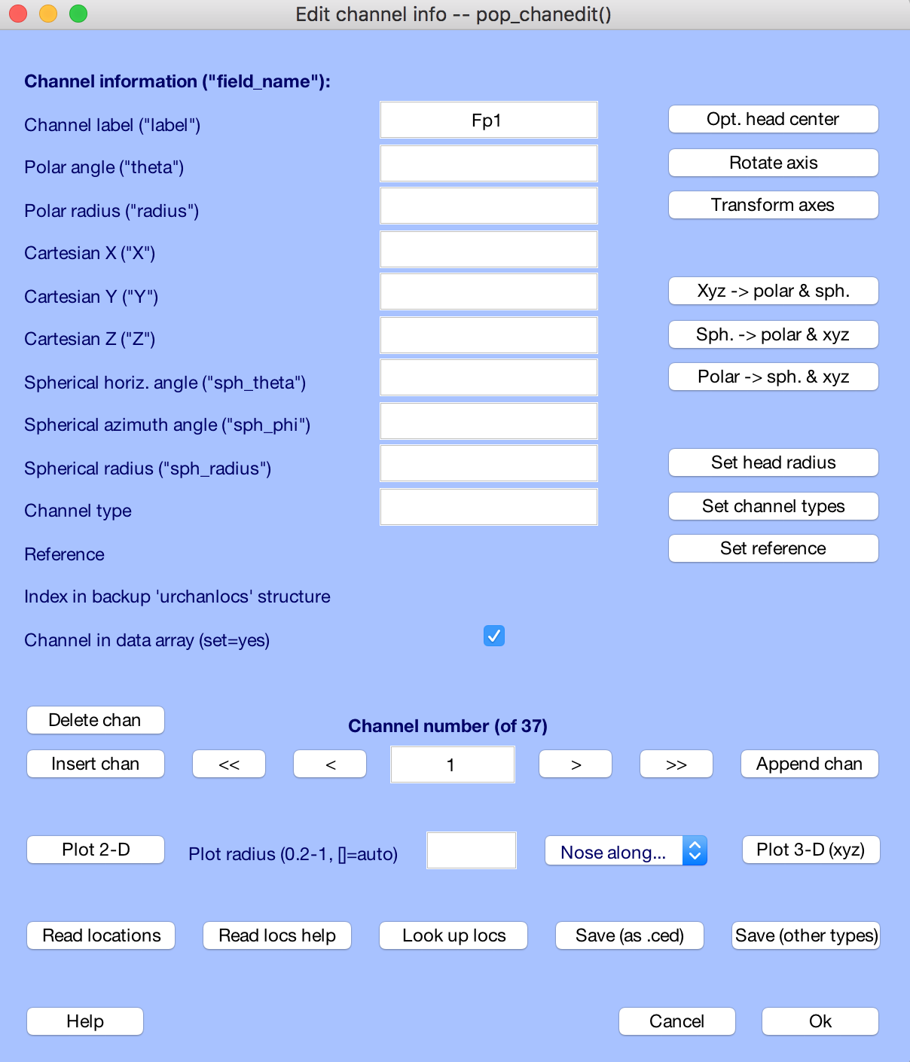

Next, click on the “Read locations” button in the lower left (highlighted in green).

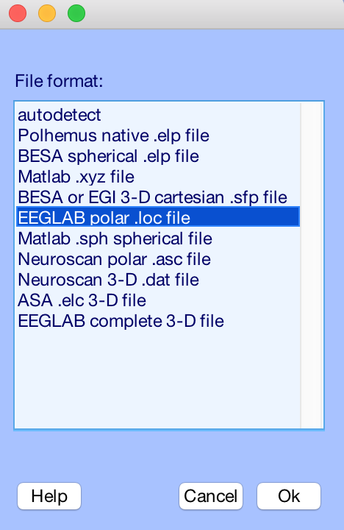Locate and select the .loc file: “chanlocs_32_3_eye_chan.locs”, which I’ll provide for you. Just be sure to remember where you store this file.

In the next pop-up window (below) select:

“EEGLAB polar .loc file” and click “Ok”

Looking back at the main EEGLab GUI, you’ll see that the “Channel locations” entry now says “Yes”.

'EEG=pop_chanedit(EEG, 'load',{'chanlocs_32_3_eye_chan.locs' 'filetype' 'loc'});'

# Running the ICA analysis

We will be using ICA analysis to find the components associated with eye blinks and saccades. This step can take a while, so if you have a paper to read, now would be a good time to get comfortable.

Select Tools → Run ICA. On a Windows machine, the default settings will work:

* ICA algorithm to use (click to select) = runica
* Commandline options (See help messages) = ‘extended’,1
* Channel type(s) or channel indices = leave blank

Click “OK” and wait for the iterative process to finish

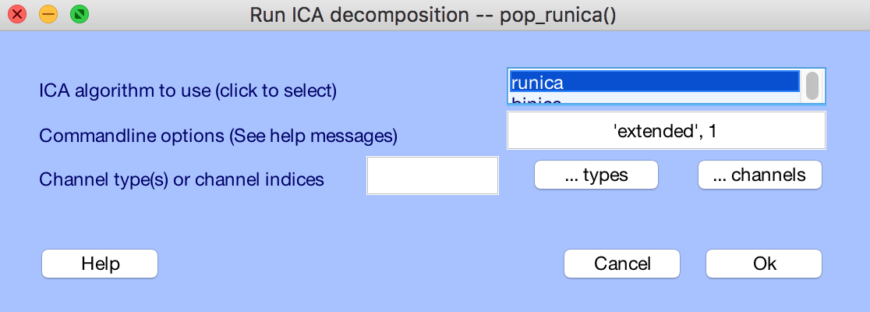

EEG = pop_runica(EEG, 'extended',1);

Note: on a Mac you can take advantage of a special C-developed library that allows you to run the ‘binica’ option. Once installed, this option makes the runtime about 12 times faster.

If you look at the main EEGLab GUI window, you’ll notice that the “ICA weights” entry now says “Yes”.

# Picking and removing the bad components

The ICA algorithm will yield 35 independent components (from the 35 channels). We need to determine which ones relate to the eye blink and saccade artifacts. Fortunately, these are pretty easy to spot, and will typically be in the first 8-10 components. We will be looking at both the scalp distributions and the component traces to figure this out.

The steps that follow cannot be automated. We’re not going to get into the “art” of EEG analysis, and how to go about identifying and rejecting artefactual data.

Select Tools → Reject data using ICA → Reject components by map. Use the default “1:35”, or all components in the “Components to plot” text window. You’ll get the following:

pop_selectcomps(EEG, [1:35] );

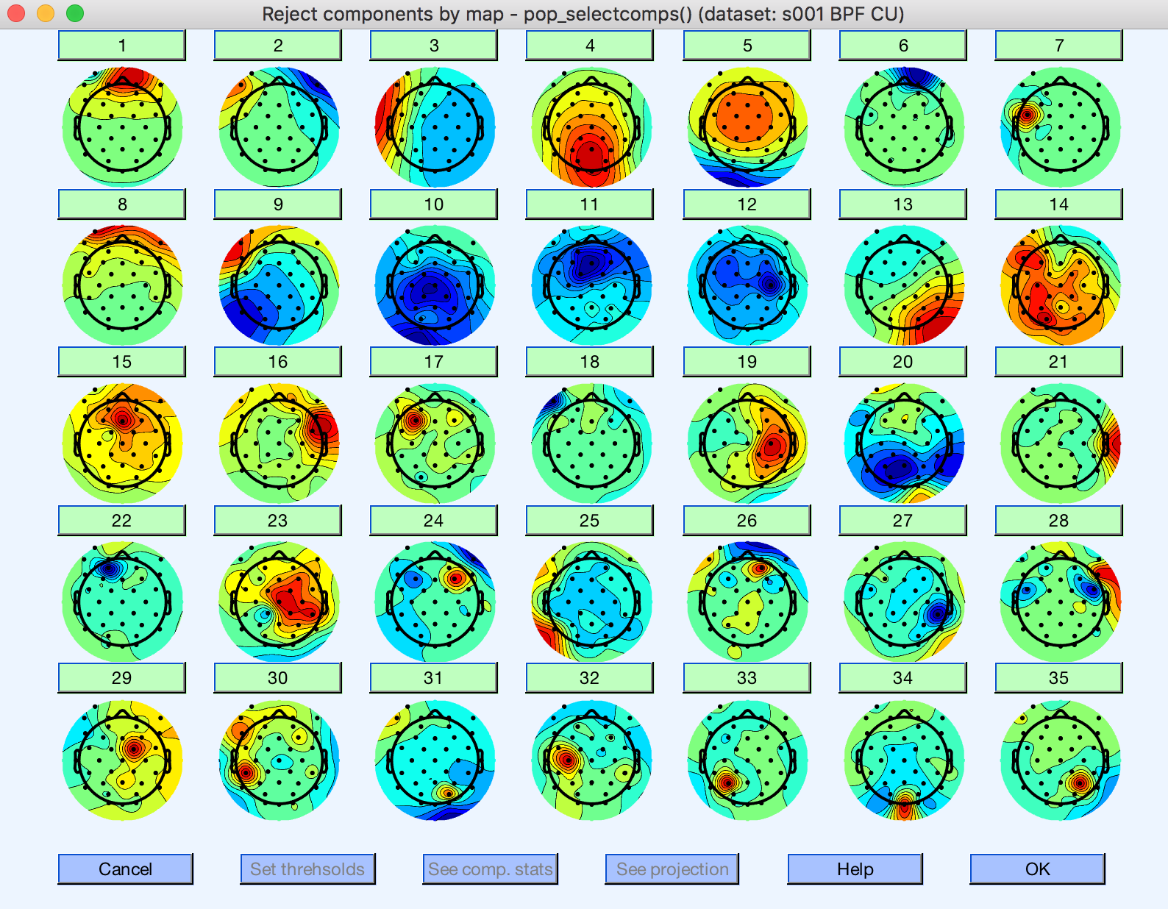

The first component is what you’ll typically see for an eye blink. We can confirm this by having a closer look at this component. Click on the green square labeled “1” just above the scalp map.

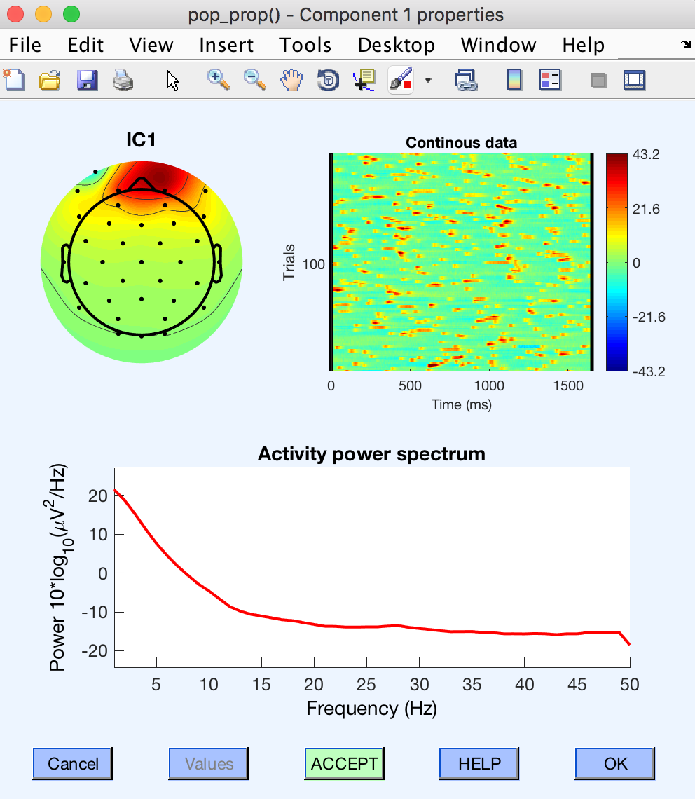The first clue was the concentrated scalp distribution both frontally and centrally.

Next, EEGLab shows you trials, which are random time slices of the continuous data set stacked one on top of the other in the upper right figure. Eye blinks are strong and happen at random intervals yielding this stereotypical speckled pattern.

Last, the “Activity power spectrum” usually has most of the energy concentrated in the lower frequencies (<10 Hz), which falls off sharply at frequencies above 10-15 Hz.

At this point, I’m certain this is the eye blink component, so we can go ahead and click on the “Accept” button to change it to a red “Reject” button. Click “Ok” to continue.

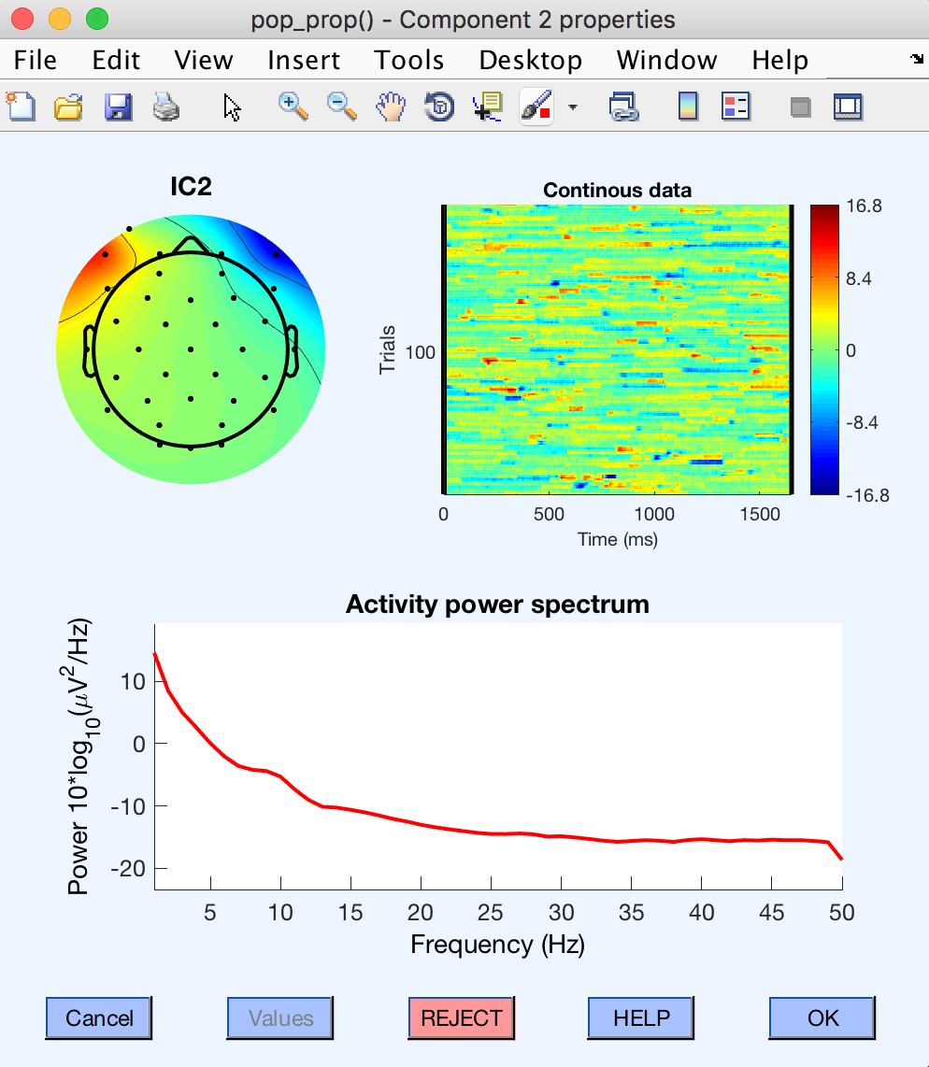Let’s have a look at component “2”.

This is a good candidate for the horizontal saccade component. The scalp distribution plot shows a frontal dipole-like pattern, and the continuous data looks similar to the eye blink data above, but the voltage goes both positive and negative.

In cases where you’re unsure whether or not to include a component it is helpful to look at the component voltage as a function of time. In this view, it is usually easy to spot activity that is unrelated to task-specific neural activity.

To view the continuous component voltages on the main EEGLab GUI:

Select Plot → Component activations (scroll). Again, it is helpful to turn off the Event information, and set the time range to display at 30 seconds. To limit the number of channels displayed, select Settings → Number of channels to display. I’ve found “8” to be a good number. You’ll have to scroll up to the first 8 channels, and will probably need to adjust the y-axis (40 seems like a good choice).

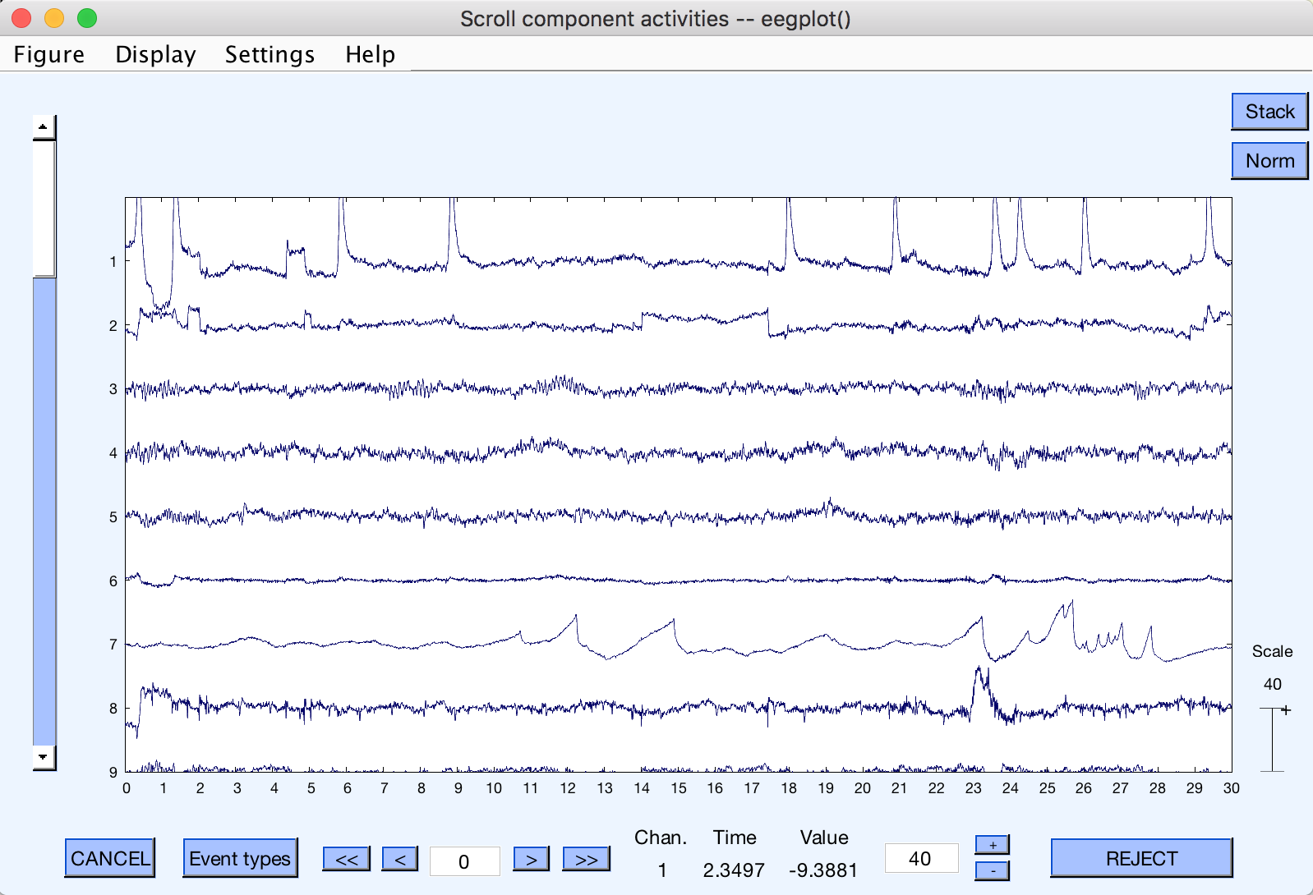

Eye blinks

Saccades

?????

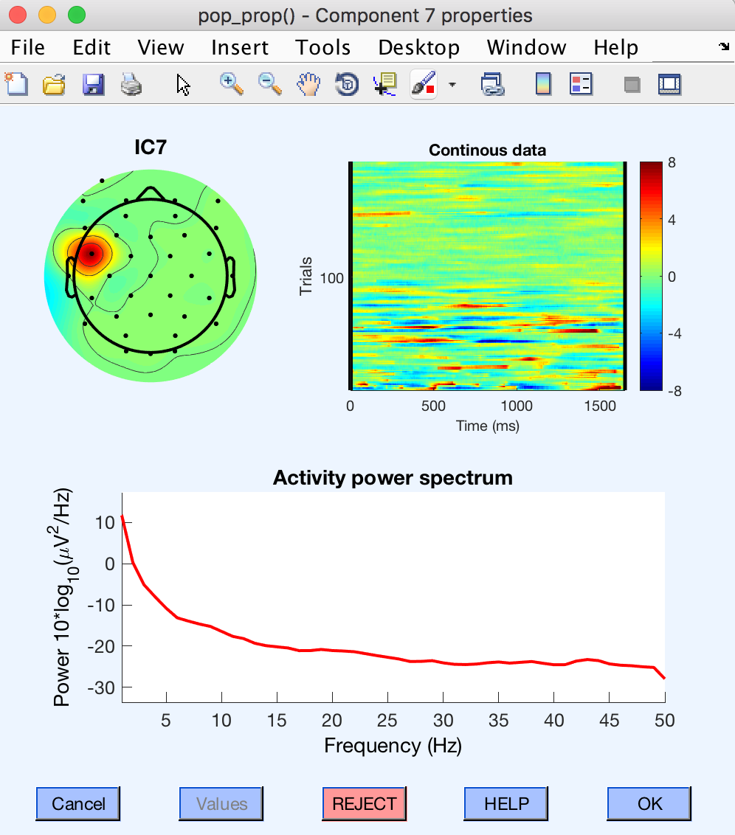You clearly can see how component 1 is the eye blink component. Component 2 shows activity that is characteristic of eye gazing behavior—in fact, it looks like what you’d expect from an eye tracker. Based on this, we can be confident in rejecting this component.

Component 7 (highlighted in orange) is a bit of a mystery. I’m not exactly sure what it is, but as I scroll through the data, it does not seem to be related to any experimental stimuli. Looking back at the scalp distributions and continuous data plots (right) it seems like this artifact is concentrated in the beginning of the experiment. I’m going to go ahead and reject this component. We can always go back and include it if we find that it negatively impacts our data.

To sum up: we’re going to exclude components 1, 2, and 7 when we reconstruct the data.

# Identifying and rejecting EKG artifacts

EKG artifact

The plot above is representative data from a different subject who exhibited a very strong EKG artifact during the recording session. I’ve been told the EKG artifact usually is the result of one of the two mastoids, so the scalp distribution will be heavily skewed to one side. Here it looks like the right mastoid was the culprit. The EKG artifact is pretty easy to spot on the Plot → Component activations (scroll) view. You can see in the red highlighted region on Component 6 the obviously periodic pulsing about once per second. Reject this component and move on.

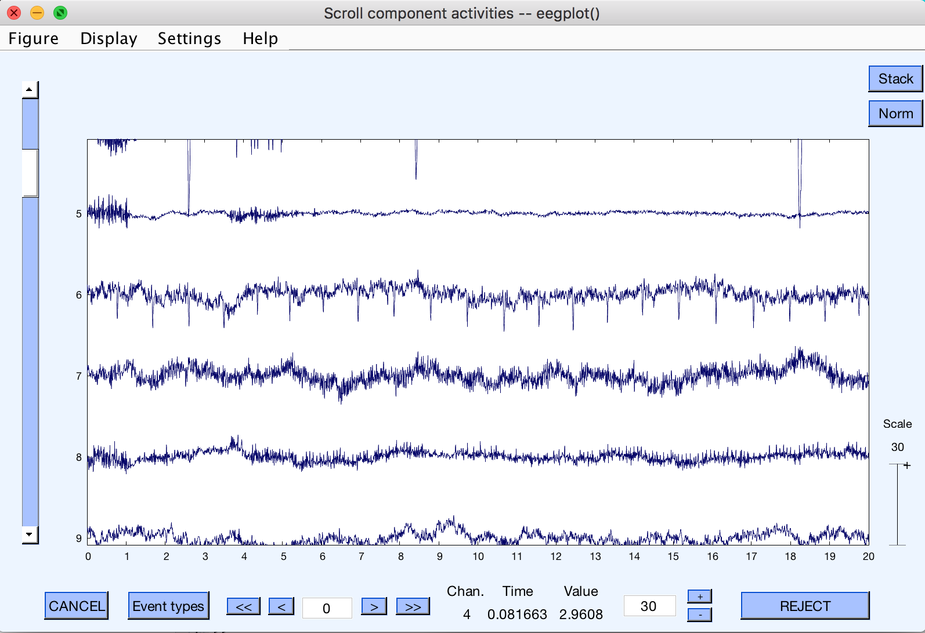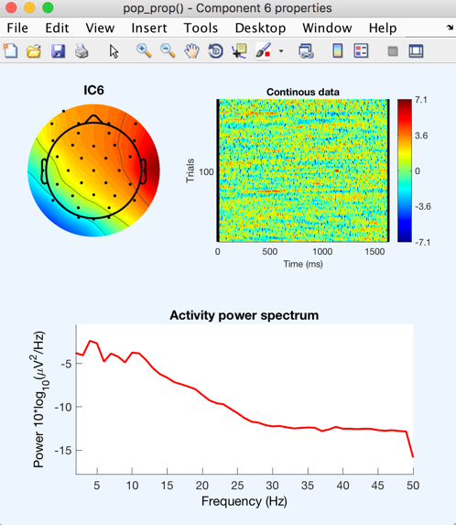

# Transferring ICA information to another dataset

Now that we calculated the independent components, we can transfer them to our non-cleaned up continuous dataset. First, make sure you’re working off of Dataset 2 (select Datasets → Dataset2:s001 BPF), then select Edit → Dataset info.

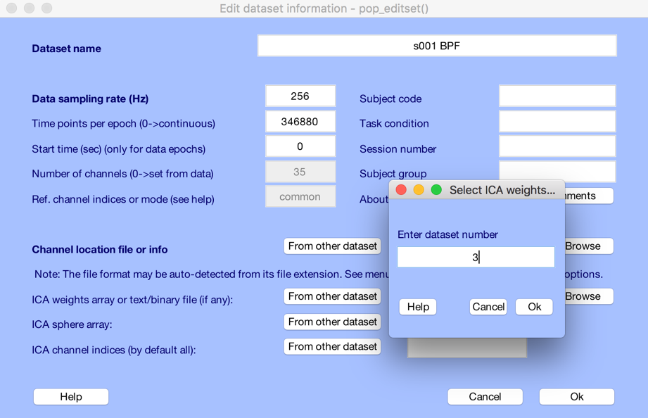

Click on the “From other dataset” button on the “ICA weights array or text/binary file (if any):” row, and enter in dataset number “3”, which corresponds to the dataset that we just computed the ICA components. Click “Ok”, and then “Ok” again.

If you go and look at the component maps (select Tools →Reject data using ICA → Reject components by map), you’ll notice that the rejected components we identified previously did not carry over. If you want, you can re-select the rejected components, although it’s not completely necessary—we’ll be able to list the rejected components in the next step.

EEG = pop_editset(EEG, 'setname', 's001 BPF ICA attLagR ER induced', 'icachansind', 'ALLEEG(10).icachansind', 'icaweights', 'ALLEEG(10).icaweights', 'icasphere', 'ALLEEG(10).icasphere');

# Rejecting ICA components and reconstructing a cleaned dataset

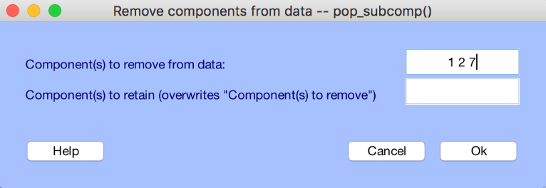We’re now going to clean up our original bandpass filtered dataset using the ICA weights were just calculated from Dataset 3. Navigate back to Dataset 2:s001 BPF by selecting Datasets → Dataset2:s001 BPF on the main EEGLab window. Double-check to see if the “Channel locations” data entry is “Yes”; if not, go back and re-add the channel locations as described previously.

Select Tools →Remove components.

If it isn’t already filled in, enter “1 2 7” in the “Component(s) to remove from data:” field, and click “Ok”.

Eye blinks

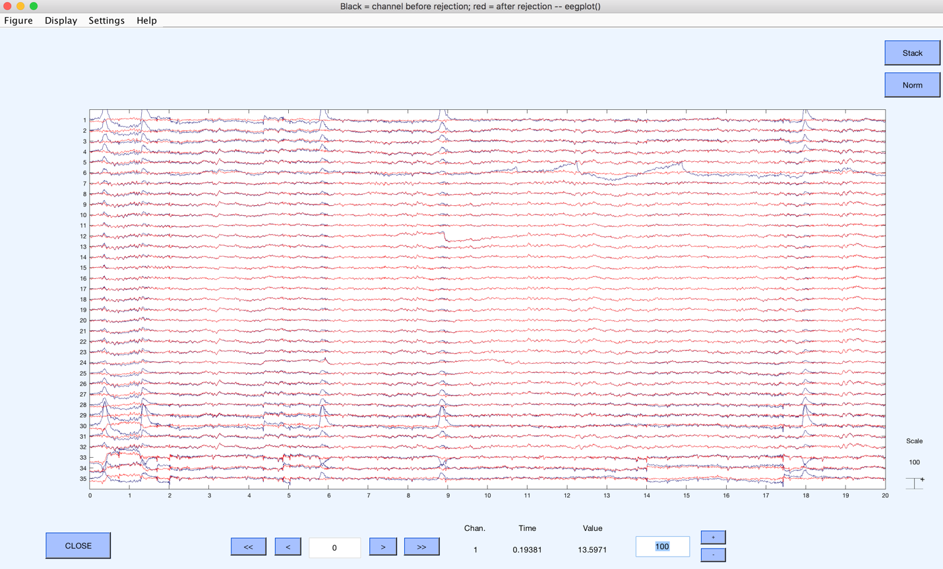

That other weird artifact

Saccades

Fiddle with the Time Range and Voltage ranges (here I selected 20 seconds and 100 µV), and scroll through the data. What you’re looking for is how well did this new ICA reconstruction address the eye blink, saccade, and other artifacts without altering the real EEG data. The blue trace is the old data, the red trace is the reconstructed data after component rejection. If it looks good, close the multi-channel data window and click “Accept”.

>> EEG = pop_subcomp( EEG, [1 2 7], 0);

Save the dataset as “s100 BPF ICA”.

[ALLEEG EEG CURRENTSET] = pop_newset(ALLEEG, EEG, 2,'setname','s001 BPF ICA','gui','off');

# Epoching the data into individual trials

Now we can epoch the data and extract out the individual trials. Select Tools → Extract epochs.

Each trial technically starts with Trigger 9, but because of our 16-bit setup, there are some extra bits that alter this number to “3849”. So…

In the “Time-locking event type(s)” field enter “”3849”.

The entry for “Epoch limits [start, end] in seconds” field will depend on the type of experiment.

* For the Visual Selective Attention Task, enter “-1.5 4.0” (1.5 secs before and 4.0 secs after Trigger 9)
* For the Auditory Selective Attention Task, enter “-0.5 4.75” (0.5 secs before and 4.75 secs after Trigger 9)

>> 'EEG = pop_epoch( EEG, {'3849'}, [-1.5 4], 'newname', 's001 BPF ICA epochs', 'epochinfo', 'yes');'

The “Name for the new dataset” should be “s001 BPF ICA epochs”. Then click “Ok”.

EEGLab will ask you what you want to do with new dataset. We’re making a new one, so go ahead and click “Ok”.

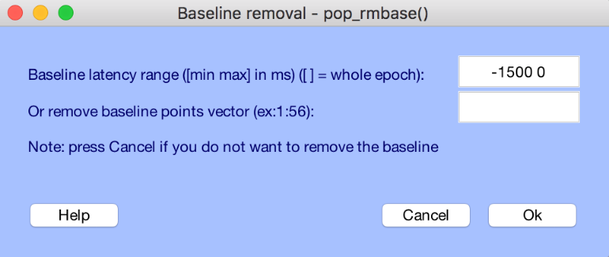Next, you’ll have the option to remove the baseline signal. EEGLab defaults to removing the average of the pre-stimulus signal (defined by the epoching event trigger, here Trigger 9) from each channel. We’re going to decline this step so click “Cancel”.

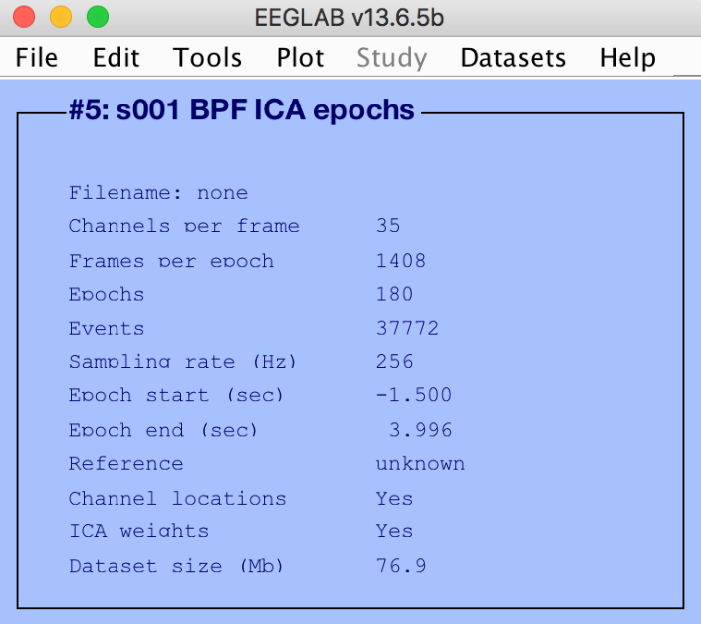Now you can see on the main EEGLab window, our new dataset consists of:

* Channels per frame = 35
* Frames (samples) per epoch = 1408
* Epochs = 180

With epoch start and stop times:

* Epoch start (sec) = -1.500
* Epoch end (sec) = 3.996

It’s not perfectly 4.0 seconds because of sample rounding, but it’s pretty damn close.

The dataset we have now explains the entire experiment tracking all 180 consecutive trials, but it doesn’t tell you what each trial is. Well…

TRIGGER KEY:

* 255 - start of entire experiment (should only show up once, maybe twice if it was paused at some point)
* 99 - beginning of trial
* 2 thru 7 - timing of visual cue according ot trial type and conditions: F = focal, B = broad, N = no supertarget, S1 = early supertarget, S2 = late supertarget
  + 2 = F_N
  + 3 = F_S1
  + 4 = F_S2
  + 5 = B_N
  + 6 = B_S1
  + 7 = B_S2
* 1 - beginning of sound
* 10 - end of trial

# Sub-dividing epochs into experimental conditions

EEGLab can select subsets of the 180 trial dataset. For each trial, I included an additional trial-identifying trigger.

* 1 = attend leading stimulus (always on left)
* 2 = passive trial
* 3 = attend lagging stimulus (always on right)

Again, because of the 16-bit convention the numbers don’t exactly match, so here’s what you’ll need to do.

First, **make sure you’re starting with your 180-epoch data set,” Dataset 5:s001 BPF ICA epochs”**.

Select Edit → Select epochs or events

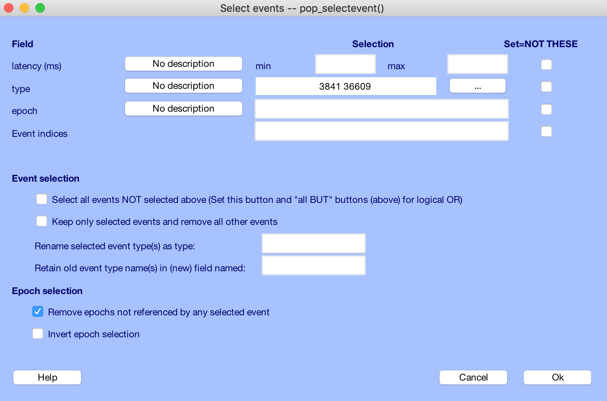

For the “type” field, you’ll enter the following numbers for each condition:

* Attend leading (left) = 3841 36609
* Attend lagging (right) = 3843 36611
* Passive = 3842 36610

BEN NOTE:

Focal = 3842 3843 3844

Broad = 3845 3846 3847

OR

No supertarget = 3842 3845

Early supertarget = 3843 3846

Late supertarget = 3844 3847

>> 'EEG = pop_selectevent( EEG, 'type',[3841 36609] ,'deleteevents','off','deleteepochs','on','invertepochs','off');'

You’ll assign new names to these newly sub-divided datasets

* For Attend leading (left), “s100 BPF ICA attLeadL”
* For Attend lagging (right), “s100 BPF ICA attLagR”
* For Passive, “s100 BPF ICA passive”

[ALLEEG EEG CURRENTSET] = pop_newset(ALLEEG, EEG, 5,'setname','s001 BPF ICA attLeadL','gui','off');

[ALLEEG EEG CURRENTSET] = pop_newset(ALLEEG, EEG, 5,'setname','s001 BPF ICA attLagR','gui','off');

[ALLEEG EEG CURRENTSET] = pop_newset(ALLEEG, EEG, 5,'setname','s001 BPF ICA passive','gui','off');

**\*\*\*AGAIN—each time you subdivide your dataset, make sure you’re starting with the 180-trial dataset, here “Dataset5:s001 BPF ICA”**

# Plotting the multi-channel event related potentials (ERPs)

Let’s look at some data! Keep in mind we haven’t rejected any of the trial epochs yet, so we’re averaging all 60 trials (good or bad) to get these ERPs. In the next step, we’ll further clean up the data by removing epochs that have extreme voltage values, but for now, let’s plot ERPs from Attend Lead (left), Attend Lag (right), and Passive all on one plot.

On the main EEGLab window, select Plot → Sum/Compare ERPs

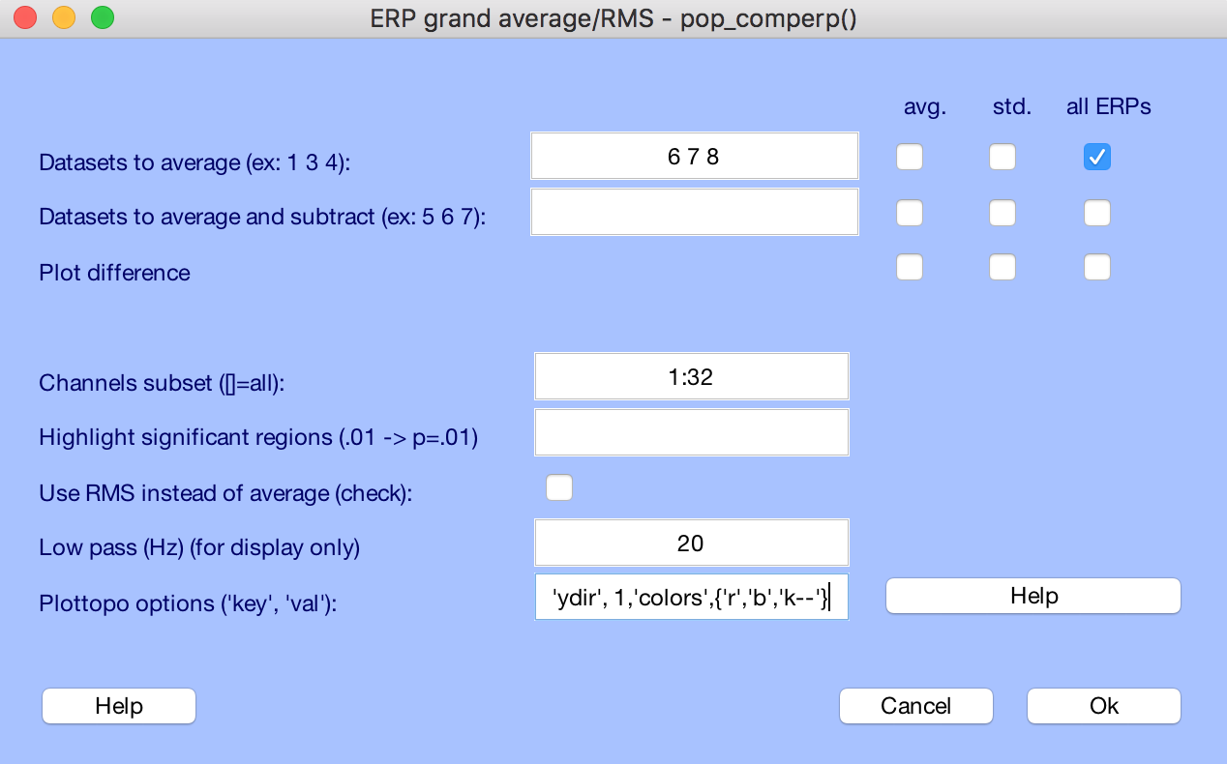

Use the following settings:

* For “Datasets to average” type “6 7 8”, refers to Datasets 6-8, naturally.
  + Uncheck the “avg.” box in the first two rows
  + Uncheck the “avg.” box in the “Plot difference” row
* For “Channels subset ([]=all):” type “1:32”, for the 32 scalp channels.
* For “Lowpass (Hz) (for display only)” enter “20”. This visually lowpass filters the data to 20 Hz, which makes the curves appear smoother and easier to interpret.
* For “Plottopo options (‘key’,’val):” we can enter in some optional parameters
  + ‘ydir’,1 : makes negative values fall below the zero line (AS IT SHOULD BE DAMMIT)
  + ‘colors’,{‘r’,’b’,’k--‘} : assigns colors and line types to each of the dataset ERPs
    - ‘r’ = red solid line for Attend Lead (left)
    - ‘b’ = blue solid line for Attend Lag (right)
    - ‘k--‘ = black dashed line for Passive
  + There are more Plottopo options. See “Help” for details.

>> pop_comperp( ALLEEG, 1, [6:8] ,[],'addavg','off','addstd','off','addall','on', 'diffavg','off','diffstd','off','chans',[1:32] ,'lowpass',20,'tplotopt',{'ydir' 1 'colors' {'r' 'b' 'k--'}});

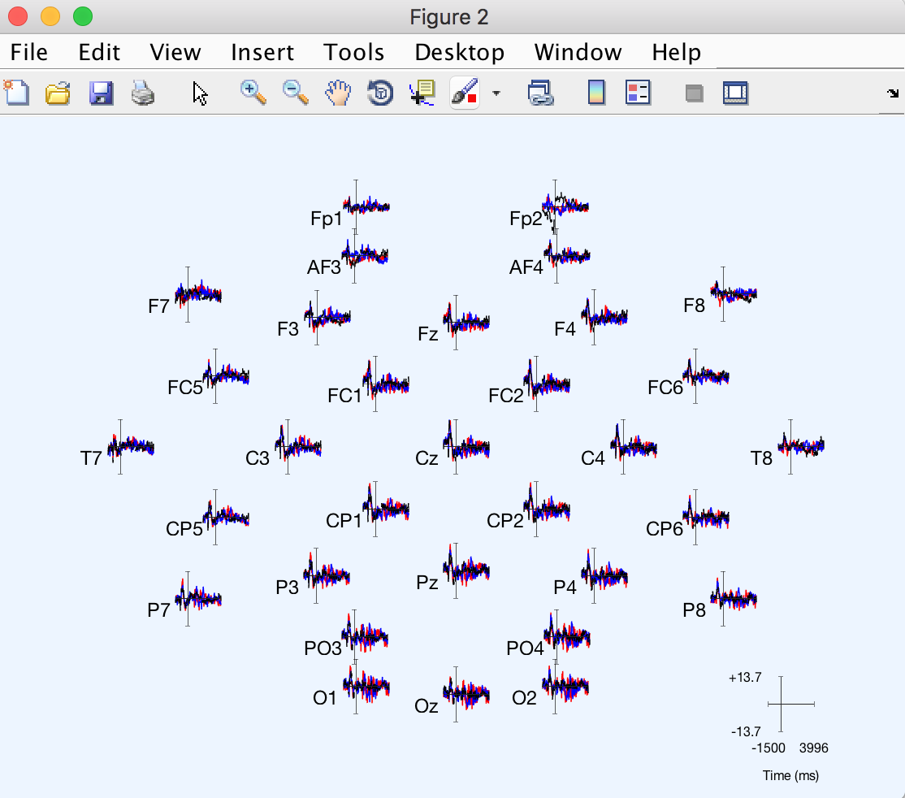

This figure is interactive. You can click on a channel to get a new pop up window. For example, clicking on channel PO3 gives you:

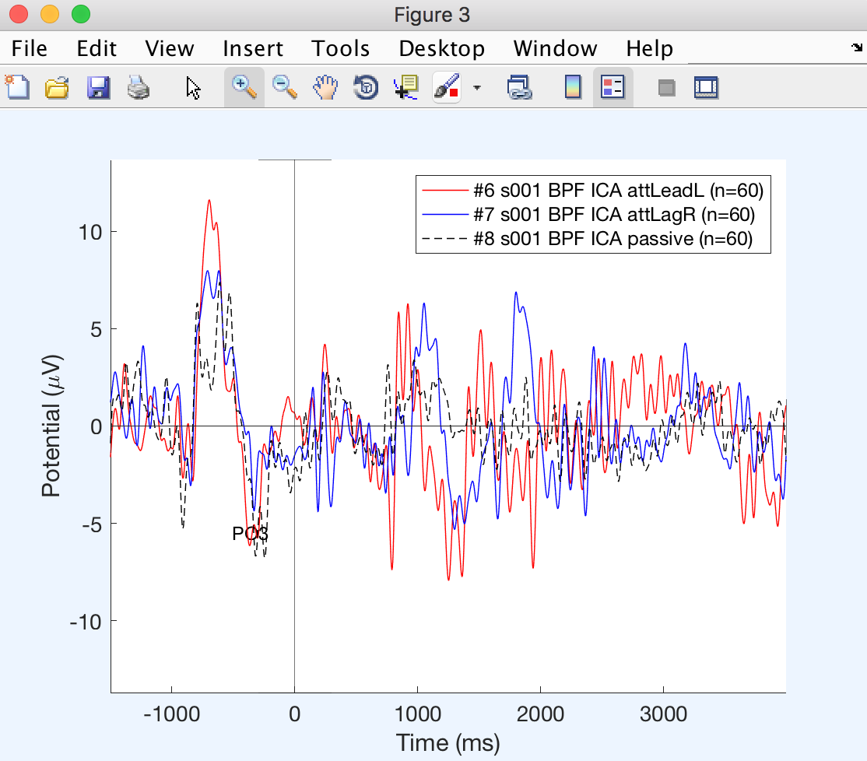

# Rejecting bad epoch data

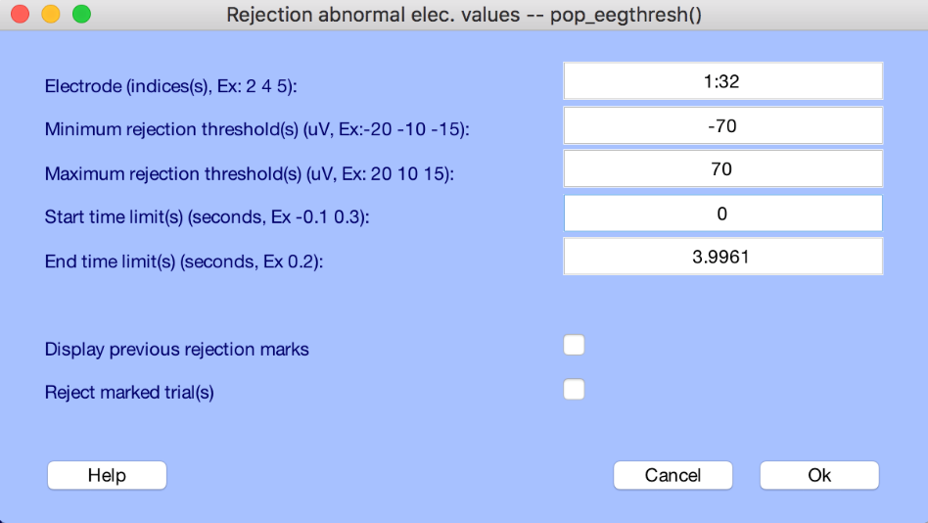Some datasets are better than others. Some subjects are better than others. Some days are better than others. Usually bad data artifacts are transient events that muck up what would otherwise be a pretty good experiment. EEGLab can select out bad epochs for you. For the purposes of this demonstration,

Select Dataset → Dataset 8:s001 BPF ICA passive

Next, select Tools → Reject data epochs → Reject extreme values

* Set “Electrode (indices(s), Ex: 2 4 5):” to “1:32”
  + We’re just interested in the scalp electrodes
* Set “Minimum rejection threshold(s)…” to “-70”
  + This value is in µV
  + This is just a starting point. Depending on the dataset you may have to fiddle with this. Most papers conservatively set this parameter to -100 µV
* Set “Maximum rejection threshold(s)…” to “70”
  + Usually the maximum threshold is symmetrically related to the minimum threshold (i.e., ±70 µV)
* Set “Start time limits(s)…” to 0
* Leave “End time limit(s)…” at 3.9961 (the default end of the trial epoch)

Click “Ok”. A pop up window will show you a multi-channel view of each epoch.

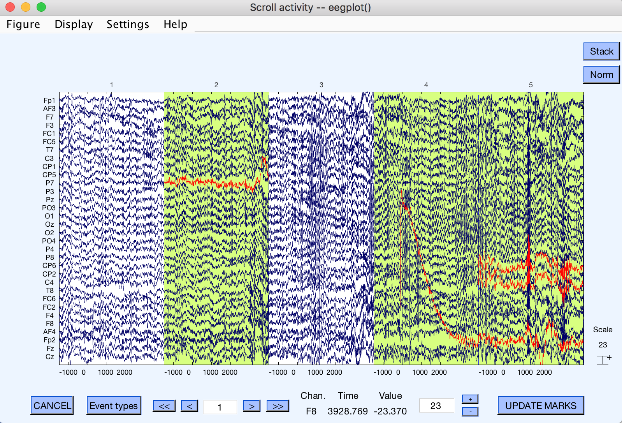

Rejected epochs are highlighted in yellow, with problem channels in red. Note, EEGLab rejects a trial if any of the 32 scalp electrodes exceed your max/min thresholds. You can scroll through the entire dataset to evaluate all of the rejected trial epochs. Once satisfied, click “UPDATE MARKS”.

EEGLab will tell you it has marked the trials for rejection, but hasn’t actually rejected them. Depending on what you want to do with this dataset, you may or may not want to toss out these trials. Right now the ALLEEG structure has stored the rejected epoch information in the data structure:

>> ALLEEG(8).reject.rejmanual

This returns a vector of 1’s and 0’s, with the 1’s representing the rejected trials. For me, this is a good dataset to save for future use—this way you can load this dataset and play around with plotting or time-frequency analysis without having to reprocess the raw dataset all over again.

If you want to reject the bad trials, select Tools → Reject data epochs →Reject marked epochs. You’ll be asked “are you sure?” Of course you are. Click “Yes”.

>> EEG = pop_rejepoch( EEG, [2 4 5 9 12 13 15 20 25 27 32 42 43 48 54] ,0);

% The vector starting with [2 4 5 9 … are the epochs that will be removed

Save the new dataset as “s100 BPF ICA passive ER”, where ER = epochs rejected

[ALLEEG EEG CURRENTSET] = pop_newset(ALLEEG, EEG, 8,'setname','s001 BPF ICA passive ER','gui','off');

You can do the same to both “Dataset 6:s001 BPF ICA attLeadL” and “Dataset 7:s001 BPF ICA attLagR”.

The entire experimental dataset was pretty good to begin with, but you’ll notice that the Passive case rejected quite a bit more epochs. Looking at the ERPs for channel PO3 using Plot →Sum/Compare ERPs

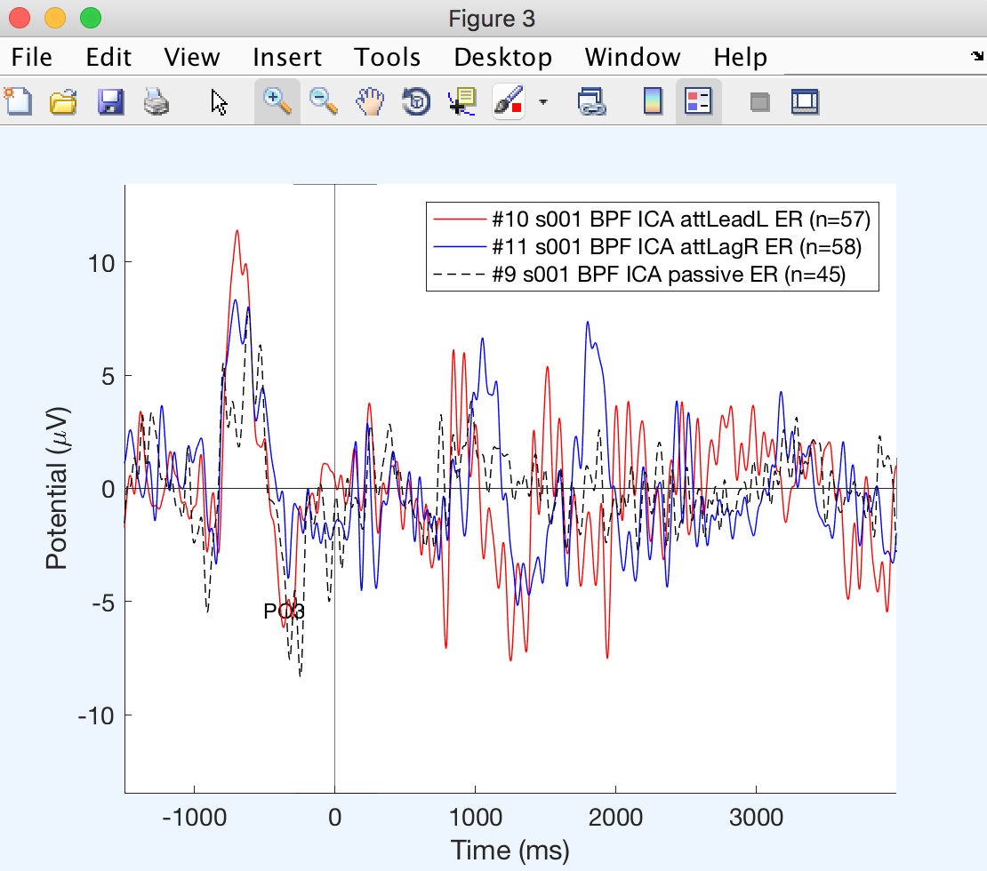You can see both the Attend Lead (left) and Lag (right) ERPs didn’t change all that much—only 2-3 trials were removed from the dataset.

The Passive condition lost 15 trials, and changed the ERP a little.

While this process can clean up your data quite a bit, it also comes at a great cost, namely, your data. Lost trials mean your estimate of the ERP variance will be affected. It will be up to you do decide how you want to deal with this trade off.

Whatever you decide, make sure you apply the same rules across all the datasets you include in your grand averages.

# Time-Frequency analysis

If you want to look at oscillatory activity, you need to get familiar with Time-Frequency analysis. Starting with “Dataset 10:s001 BPF ICA attLeadL ER” select Plot → Time-frequency transforms → Channel time-frequency.

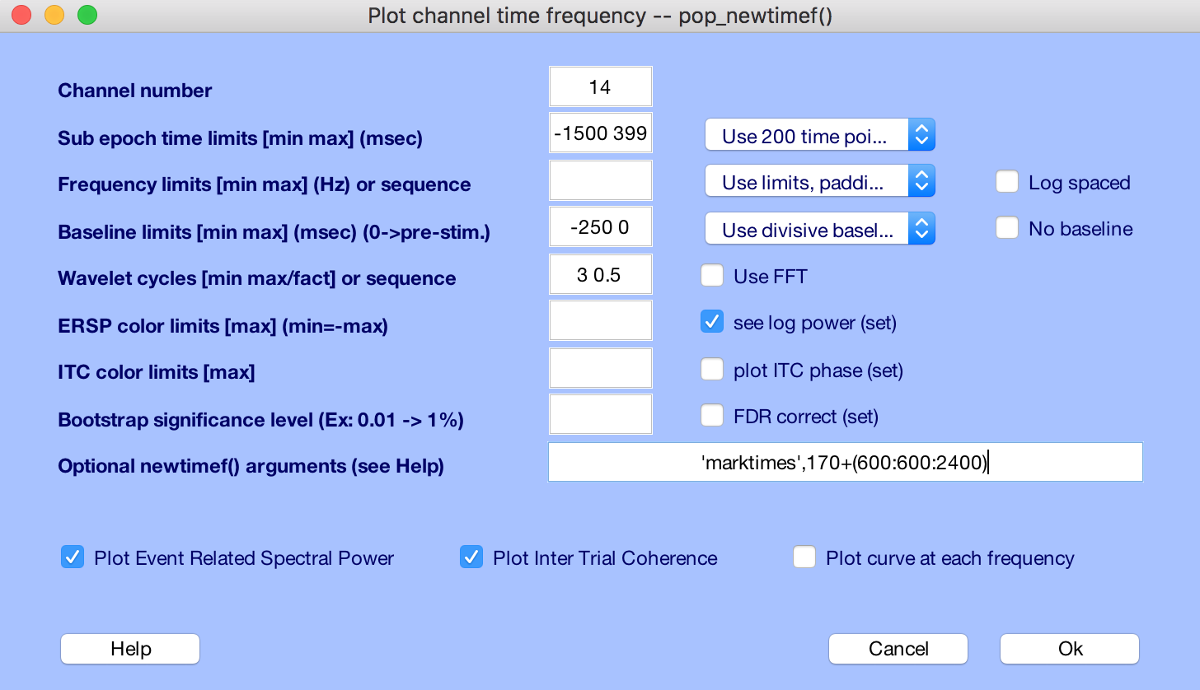

We’ll have a look at channel PO3, which is channel #14. TIP: You can have EEGLab plot out scalp channel locations by number by Plot → Channel locations → By number.

Set the following parameters:

* Channel number = 14 (for PO3)
* Sub epoch time limits [min max] (msec) = -1500 3996 (default)
* Baseline limits [min max] (msec) = -250 0 (we’re going to use the 250-ms before the stimulus onset)
  + The event-related spectral perturbation (ERSP) shows within-frequency-band power deviations from this baseline period
* Wavelet cycles [min max/fact] or sequency = 3 0.5 (default)
  + We’re using wavelet analysis instead of Fourier analysis
* Optional newtimef( ) arguments = ‘marktimes’,170 + (600:600:2400)
  + This will insert time landmarks on the plot at the right times
  + I know that visual evoked N1s happen around 170 ms post stimulus onset, and that the leading stimulus happens every 600 ms starting at t = 600 ms

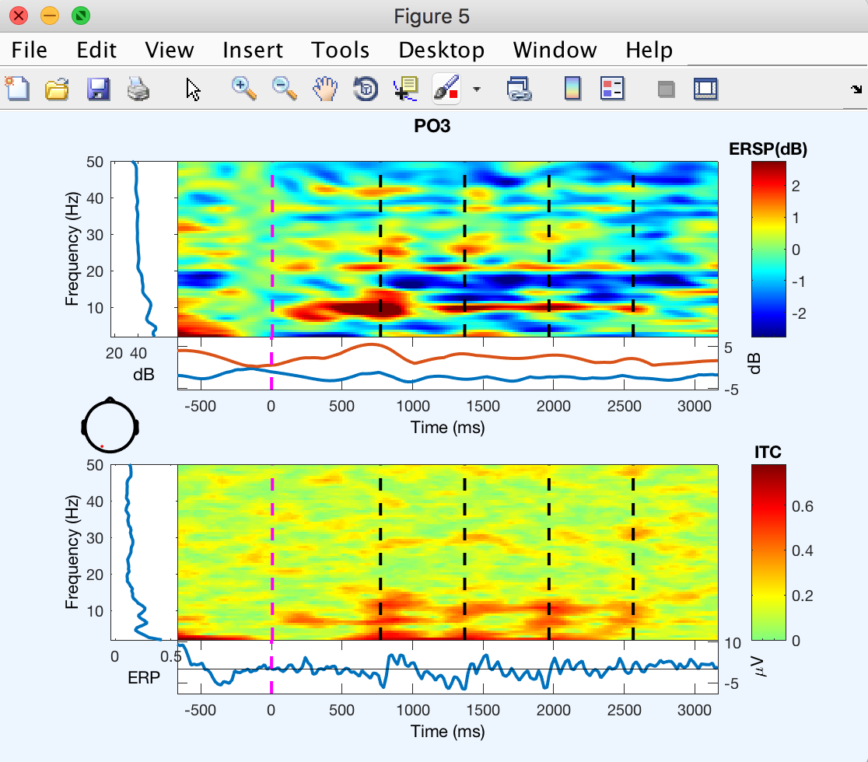

The ERSP describes the change in power relative to a calculated pre-stimulus baseline.

The ITC describes how synchronous the frequency content is from trial to trial.  It’s a normalized score, which is to say an ITC = 1 means every trial response is identical and ITC = 0 means the phase of the frequency components is completely random.  I think of it as a histogram of phases as a function of frequency as you scroll across time.  In other words, each column of pixels is your “phase histogram.” Here, you can see we have increased ITC scores at time points that correspond very nicely to the predicted N1 onsets of the 4 arrows of the Leading stimulus.

What about the ERSP? Well, it certainly looks like we have evoked power increases relative to the 250-ms pre-stimulus baseline in the alpha range (~10 Hz) and the gamma range (20-40 Hz). These likely reflect the onset responses of the leading stimulus sequence. If we wanted to look at induced oscillations we would subtract off the evoked ERP from each trial and recalculate.